

SAFE Midwest Participant Guide
Table of Contents


 | Welcome and Workshop Overview
TAB 1 | Establishing a Healthy Culture
TAB 2 | SAFEty Principles
TAB 3 | 3Cs and Behavior
TAB 4 | Feedback
Tab 5 | Reflection and Commitment Worksheet and Discussion Guidance

SAFE: What it is, what it does, why it’s critical

What it is
SAFE is a two-day immersion, leadership development workshop that features presentations, learning activities, and application through scenario practice. The SAFE Academy is modelled on the Battelle LOSA program, and began as a collaboration between LBL, LLNL, and LANL and their respective HR and OPS organizations. SAFE quickly expanded to include SNL and more recently ANL and SLAC. Due to its growth, SAFE is now expanding regionally in an effort to accommodate more students and prove to be more equitably and financially distributed.

What it does and why it’s critical
SAFE’s objective is to strengthen participant’s awareness of how critical their role is in fostering a healthy and shared culture, and then give them a “safe” and structured environment to practice the behaviors that help them create those productive and safe working environments. And why is that so important? Because healthy and safe working environments correlate with our ability to realize mission as well as bottom-line business goals. Oh, and let’s not forget that employees also stay with employers who value and engage them and who create safe working environments. Not just physically safe environments but psychologically safe ones…where it’s okay to be vulnerable, make a mistake, know you’ll get acknowledged for the work you do and not have someone claim it as their own, accept and give feedback because you know it was delivered with the best intentions. Succinctly put, SAFE helps leaders improve engagement with direct reports in order to enhance human and organizational performance outcomes.

Program Structure
- Presentations and Setting the Foundation – Morning of Day 1
  - Event review – A participating Labortory COO
  - Safety Priniples – A participating Laboratory ESH Director
  - Introduction to 3C and Behavior – A participating HR Facilitator
  - Providing Feedback – A participating HR Facilitator
- Scenario Practice – Afternoon of Day 1, Moring of Day 2
- Teams of seven: five participants, one OPS Facilitator, and one HR Facilitator
- Staged concept mastery: baseline scenario, large group debrief, conscious application scenario

SAFE Southwest Workshop Schedule – Day 1

DAY 1
Welcome, Introductions, Program overview, Agenda | 8:00 a.m.
COO Presentation | 8:20 a.m.
Safety Principles | 8:50 a.m.
Break | 9:20 a.m.
3Cs | 9:30 a.m.
Giving Feedback | 10:15 a.m.
Break | 11:00 a.m.
Scenario 1 | 11:15 a.m.
Working Lunch – Large Debrief (Intro to psych/physical safety; what must go right) | 12:00 p.m.
Scenario 2 | 1:00 p.m.
Scenario 3 | 1:45 p.m.
Break | 2:30 p.m.
Scenario 4 | 2:45 p.m.
Scenario 5 | 3:30 p.m.
Large Group Debrief (Intro to Everyone’s a Leader, Active Bystander Awareness, Diversity and Inclusion) | 4:15 p.m.
Close | 5:00 p.m.
Group Dinner | 5:30 – 7:30 p.m.

SAFE Southwest Workshop Schedule – Day 2

Day 2
Lessons Learned Review | 8:00 am
Scenario 6 | 8:15 am
Scenario 7 | 9:00 am
Break | 9:45 am
Scenario 8 | 10:00 am
Scenario 9 | 10:45 am
Scenario 10 | 11:30 am
Working Lunch, Self-Reflection and Panel Prep | 12:15 pm
Panel | 1:20 pm
Certificate presentations | 2:20 pm
Wrap Up, Comments, Evaluations | 2:35 pm
Close | 2:45 pm

Panelists:

SAFE Southwest Participant Teams

The Goal of SAFE

The Safety Academy for Excellence (SAFE) has been designed to increase the awareness, skills, and consequently the resilience of all employees by strengthening those capabilities in our supervisory and managerial leaders first. It is intended to prepare and empower our front-line supervisors in our collective effort to build a stronger, safe and healthy culture.

SAFEty Principles
- Everyone is personally responsible for ensuring safe operations
- All staff value the safety legacy they create in their discipline
- Staff raise safety concerns because trust permeates the organization
- Cutting-edge science requires cutting-edge safety
- A questioning attitude is cultivated
- Learning never stops
- Hazards are identified and evaluated for every task, every time
- A healthy respect is maintained for what can go wrong AND What Must Go Right

Key Messages
- We must evaluate risk through both a psychological AND physical lens
- We must reinforce and focus on the “what must go right” and DOES go right in equal proportion to evaluating what could go wrong
- Everyone is a leader and accountable for the culture that exists
- Every voice matters; inclusion, acknowledgement, and appreciation for all perspectives is necessary and beneficial, as well as considerate

SAFE Objectives

Foundational Objectives
- Each supervisor understands and can generally describe how:
    - their behavior impacts and shapes the local environment and broader culture
    - their behavior aligns with the SAFEty principles and applies to their specific responsibilities
    - they will apply the behavior and honor the principles to improve the safety culture that they guard
- Each supervisor better understands their front-line supervisory strengths and weaknesses and has a plan for enhancing their on-the-job performance and the quality of their field presence
- Supervisors self-reflect on behaviors that may contribute to vulnerability in the safety culture and identify action(s) they will take when they return to their lab to mitigate this vulnerability
- Each participant gains a value-added support network of peers and operational leaders

Key skill Objectives
- Supervisors demonstrate their ability to foster questioning attitudes so that hazards are understood for every task every time
- Supervisors demonstrate their ability to effectively lead and coach with specific attention on reinforcing each employee’s value and accountability in realizing mission AND shaping healthy culture
- Supervisors demonstrate their ability to build the trusting relationships that allow others to be vulnerable, ask for needed help, and actively and confidently shape healthy culture

Approach objective
- Simulation-intensive learning experience that effectively integrates awareness, reflection, and immediate individualized feedback

Insert tab 1 – COO/Culture Kick-off slides here
  - Remove this page before printing
  - Place colored/blank page between tabs

Insert tab 2 – ESH/Principle slides here
  - Remove this page before printing
  - Place colored/blank page between tabs

Insert tab 3 – Insert 3C slides here
  - Remove this page before printing
  - Place colored/blank page between tabs

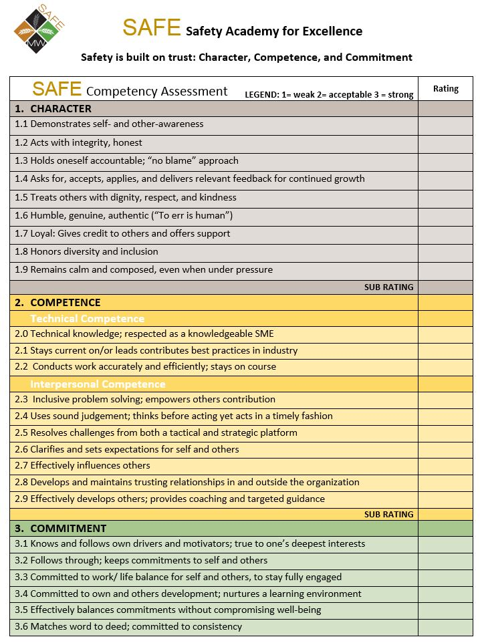

Insert tab 4 – Insert Feedback slides here
  - Remove this page before printing
  - Place colored/blank page between tabs

Insert tab 4 – Insert Feedback slides here
  - Remove this page before printing
  - Place colored/blank page between tabs

Giving Effective Feedback



Feedback
Increase
individual & team effectiveness

Feedback has the potential to transfer energy from undesirable behavior to desirable behavior. Effective feedback helps individuals and teams improve and develop a practice of continuous improvement. This can lead to increased respect for oneself and one's teammates as well as increased confidence and mutual support. As managers deliver more and more effective feedback, their organizations can move into the future with greater ability to solve problems and recognize and take advantages of new opportunities.

Feedback is typically one-way communication; One person telling another person how they did/didn't perform or behave in comparison to the expectation.

Feedback is information that:

- That helps people consider whether they will change their behavior
- That helps people learn how well their intentions match their behavior/actions
- That is constructive, considerate and useful

What Gets in the Way of Giving Feedback?
Despite the value of giving feedback, it can still be challenging to provide it.

What gets in the way of you providing consistent positive and constructive feedback? Discuss in your table groups:



The Triune Brain: Learning and Change
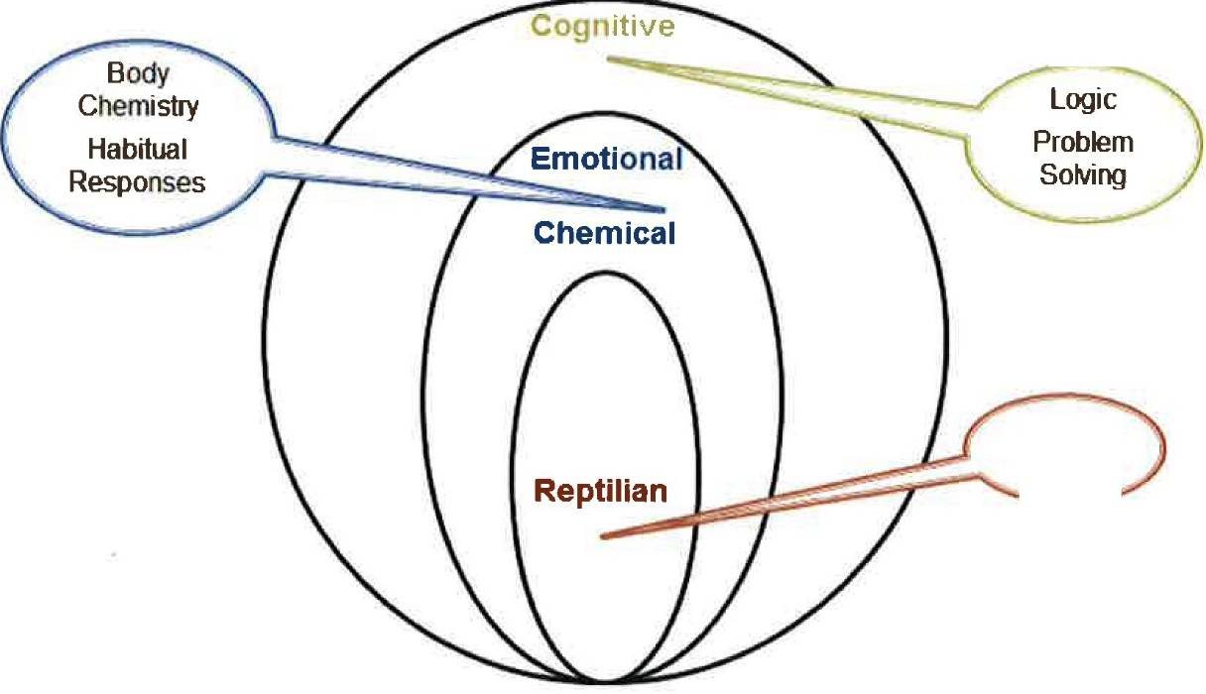
Fight or
Flight
Figure 9,1

Reptilian Brain
Controls autonomic functions; operates purely on instinct and consists of fight, flight, freeze or reproduce.

Emotional/Chemical Brain
Controls body chemistry; operates short-term based on habitual responses to stimuli. Many habits are learned before a person can choose them or influence them using intellectual understanding or control. Most people have enough habits to be able to get through 80% of each day without truly engaging intellect.

Cognitive Brain
Controls abstract thinking and provides the ability to create and use models, symbols (language) cause and effect thinking, relationships, and logic. One can problem-solve, invent new models, project into the future and change old habits.

Practical and Personal Needs
Each feedback interaction has two key needs. Personal and Practical

Practical Needs
- To have a constructive conversation with a productive outcome:
- Sample Communication Goals/Outcomes:
  - Share information
  - Influence/gain buy-in
  - Gather input or feedback
  - Solve a problem
  - Addresses Issues
  - Resolves a conflict
  - Outlines Processes
  - Clarify Roles and Responsibilities
  - Build Relationships
Personal Needs
- Give and receive respect
  - Be direct and sincere
  - Be honest
- Interact with empathy
  - Reflect and identify feelings
  - Be considerate of others' emotions
- Encourage involvement
  - Ask open questions
  - Practice active listening
  - Give/receive feedback
- Build trust
  - Build trust by being open
  - Show your thought processes and reasoning

Notes:

Before You Give Feedback

There are three Key Elements that must be in place before you can deliver successful feedback:

Clear Expectations
People need to know what procedures and results are expected. Expectations for both behavior and performance must be clear and not ambiguous. The expectations should not be in conflict with one another. Lastly, the expectations must be realistic given the employee's skills, knowledge, and resources.

Control of Resources
People must have control of all the resources necessary to meet and exceed the expectations.

You have Observed and Assessed
You are able to clearly tell how well they are doing in relationship to the expectations.

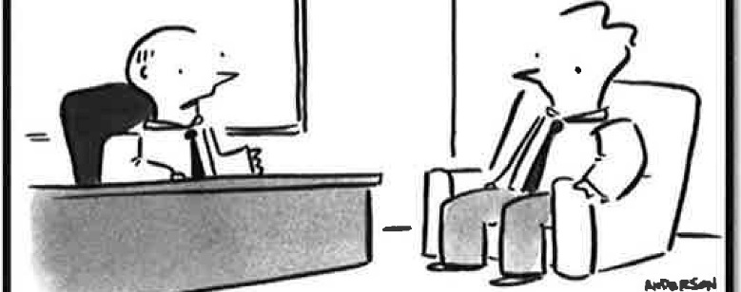

"You're a go-getter, but what I need is more of a bring-backer."

Feedback Model - Positive Feedback

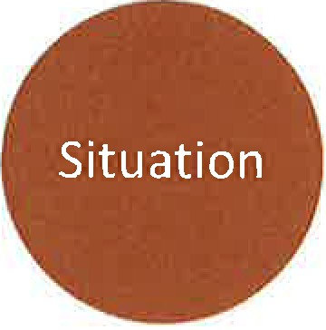 + 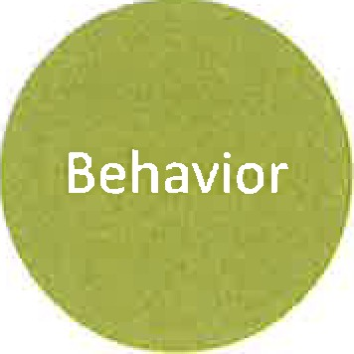 = 

Situation (Summary): What was the assignment and/or accomplishment expected?

Behavior (Strengths & Increased Emphasis): How did it get done (what competencies, skills, knowledge or abilities were utilized)?

Impact (Assessment or Appraising): What was the result and or impact (significance of the worth, value or merit)?

Positive Feedback Example:

- “Yesterday, in/at the (situation – meeting, luncheon), when you did (behavior), it was impactful because it (imp

Identifying Specific Behaviors
Focusing on behavior instead of attitude or personal characteristics provides employees with information they can use for improving their performance.
Where necessary, rewrite each of the following statements so that it describes specific behavior rather than attitude or personal characteristics.

- Andre shows initiative in completing his safety training ahead of schedule.

S&B:

I:

- Bob is a team player.

S&B:

I:

- Jeanne is great at identifying safety hazards.

S&B:

I:

- Maria has always been conscientious about her work.

S&B:

I:

Using your own examples apply the model to the feedback you wish to provide

Positive Feedback:
“When you did/said __________________________________________________________
______________________________________________, that was (impactful, positive,
made a difference) because it resulted in ________________________________________.”

Feedback Model - Constructive Feedback
Use constructive feedback to address behavior change and/or performance improvement. Like positive feedback, always focus on specific behavior, not attitude or personal characteristics.

S ituation | What was the "Situation"?
B ehavior | How did their specific "behaviors" contribute to the situation?
I mpact | What is the "impact" of this behavior (to you, to the project, to the team, etc.)
F uture Expections | What are the "future expectations" you have relative to the behavior change or performance improvement?

Notes:

Skill vs. Will
The chart below can be used as a guide to determine the appropriate approach to the way in which to coach your partner. Depending on their skill & will, determine whether a shaping or responding approach would be more appropriate.


Challenge
- Communicate trust
- Develop stretch goals, broaden responsibilities, treat as “partner”
- Provide positive feedback

Instruction
- Build the skill by providing tools, training, and guidance
- Allow for mistakes
- Relax control and provide positive feedback as progress is shown

WILL

Engage/Motivate
- Identify reason for low will (what do they take most pride in/how do they like to be recognized)
- Provide clear expectations and vision of success
- Monitor and recognize positive behaviors

Direct
- Provide clear expectations and vision of success
- Determine training needed
- Structure “quick wins,” supervise with frequent feedback, both positive and constructive as needed



SKILL

Constructive Feedback Skill Practice Preparation
Identify a situation where you need to provide feedback. Alternatively, identify a feedback situation from the past that you would like to do-over. Based upon the situation, determine which Skill vs. Will quadrant the employee falls.

Use the space below to construct the feedback conversation.

Situation (describe the specific situation):

Behavior (describe the specific behavior/performance that needs to improve):

Impact (describe the impact of this behavior):

Future Expectations (describe the behavior/performance you expect going forward)

How will you incorporate the Skill vs. Will quadrant information into this feedback discussion and into the necessary follow-up?

Constructive Feedback Observer Worksheet

NOTES
s
What was the "situation"?
B
How did their specific "behaviors" contribute to the situation?
l
What is the "impact" of this behavior?
F
What are the "future expectations" of the supervisor?
SKILL/WILL
Which quadrant has the supervisor placed the employee? How will this be incorporated into the feedback discussion and
necessary follow-up?

Feedback for your partner:

Insert tab 5
  - Remove this page before printing
  - Place colored/blank page between tabs
  - Print reflection worksheet on 11x17 and place behind Post Workshop Discussion page; fold 1/3 of page in to fit

SAFE Reflection and Commitment Discussions – Post Workshop

Following the workshop, we want to offer you the opportunity to reflect on your experience here at SAFE and plan some actions forward to keep your learning and influence on healthy culture going strong. To that end, we encourage you to set up a 30-minute Reflection and Commitment Discussion with both of your Facilitators. Below are some directions on how best to do that.
Arranging the Discussion
- You are responsible for arranging the 30 minute Reflection and Commitment Discussion you’re your respective HR and OPS Facilitators
  - The discussion should occur no farther out than 1 month after the workshop
  - First, get both of your Facilitator’s email addresses so you may make contact following the workshop
  - Within one week after the workshop, send your facilitators an email/meeting invitation
  - This will be a remote discussion over the phone, so a conference line will be necessary
    - Please send call in information to both facilitators in advance of the call
Preparing For and Holding the Discussion
- Remember to have your SAFE Reflection and Commitment Worksheet there for the discussion
- If you wish to, email your Worksheet to your facilitators in advance of the meeting
- Your HR Facilitator will kick off the session, yet please use your time to cover your insights/learning/actions coming out of the SAFE workshop
- End with a focus on the future: how do you move your workplace and culture moving forward?

