Introduction to Human Performance Improvement

Safety and Performance Through Self-Awareness

Participant/Facilitator Guide

Intentionally left blank


Safety and Performance Through Self-Awareness
Welcome to Safety and Performance Through Self-Awareness. This information highlight Human Performance Improvement at an individual level.

Facilitator Notes:
Welcome the participants to the course.

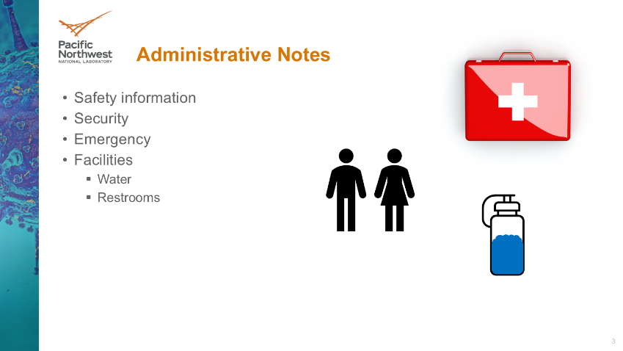
Administrative Notes
The facilitator will explain safety, emergency, security, and other information during this section of the course. The information is relevant to the time and location of the live event.

Facilitator Notes:
Inform the participants and attendees of the site-specific safety, security, and emergency requirements and the actions to take in case of an emergency. Additionally, inform the participants and attendees of the restrooms, water fountains/fill stations, and any other information relevant to the site and their comfort and safety.

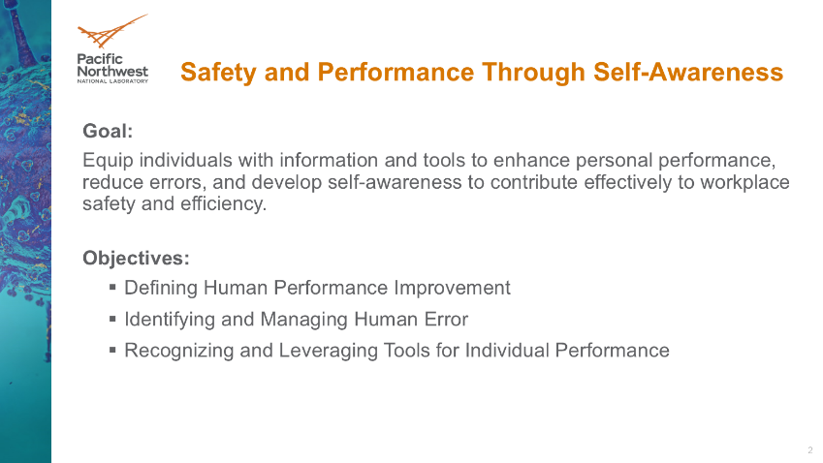
Purpose
In pursuit of a safety culture, we identified a small, yet relevant area of Human Performance Improvement to focus on. This area is the individual. The goal is to equip individuals with information and tools to enhance personal performance, reduce errors, and develop self-awareness to contribute effectively to workplace safety and efficiency. In the spirit of this goal, we will focus on three objectives:

- Defining Human Performance Improvement
- Identifying and Managing Human Error
- Recognizing and Leveraging Tools for Individual Performance

Facilitator Notes:
Inform the participants of the overall purpose of the event.

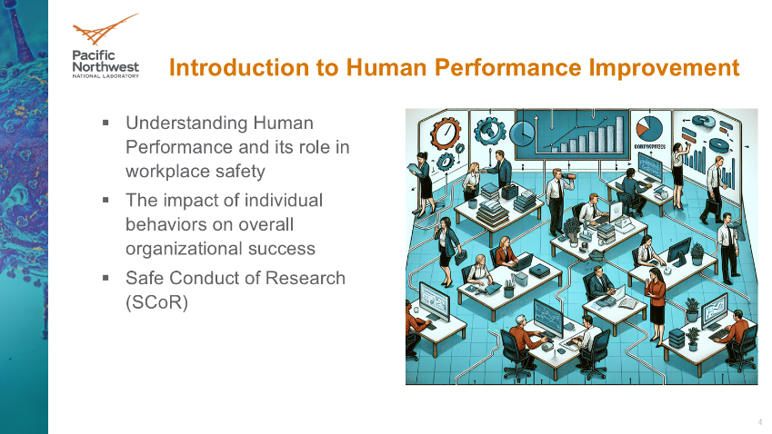
Introduction to Human Performance Improvement
.

Facilitator Notes:
.

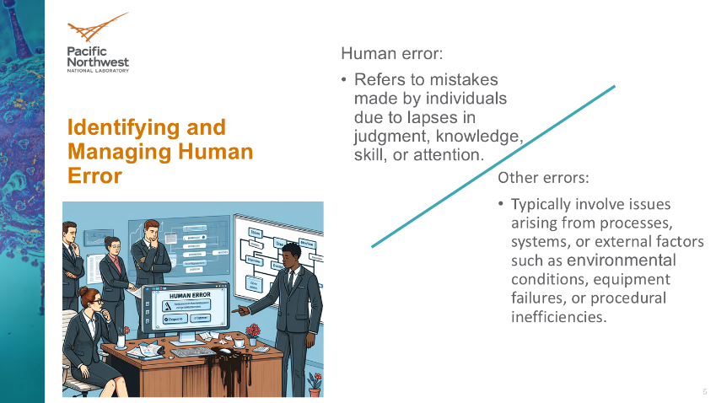
Identifying and Managing Human Error
.

Facilitator Notes:
.

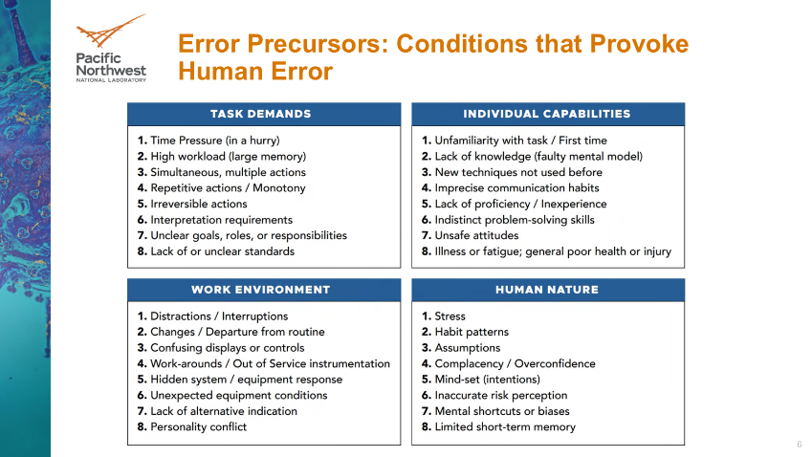
Error Precursors: Conditions that Provoke Human Error
.

Facilitator Notes:
.

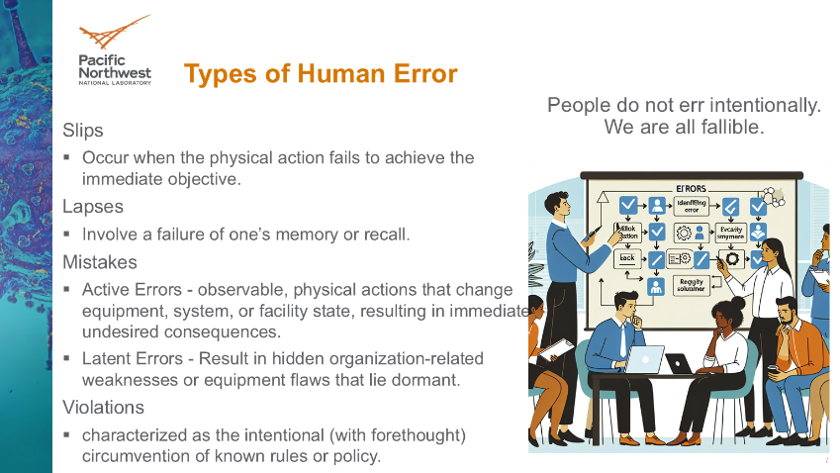
Types of Human Error
.

Facilitator Notes:
.

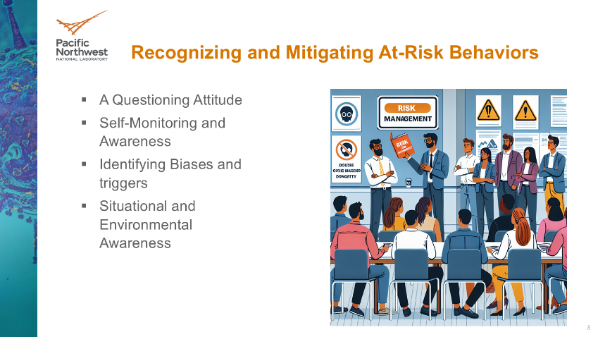
Recognizing and Mitigating At-Risk Behaviors
.

Facilitator Notes:
.

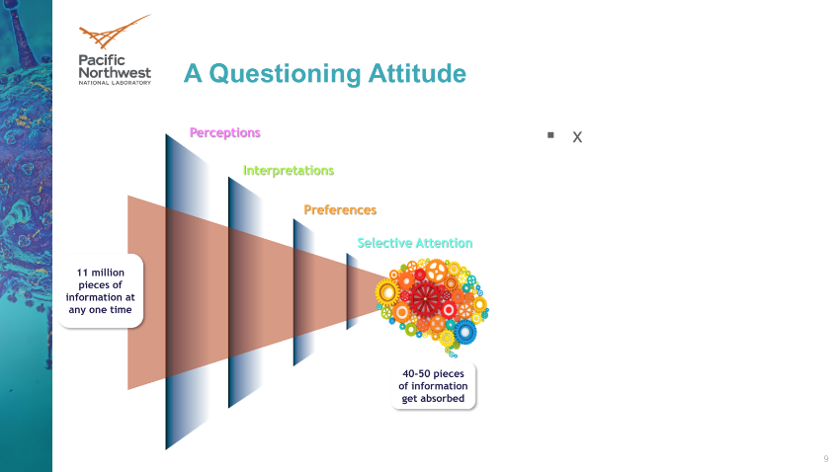
A Questioning Attitude
.

Facilitator Notes:
.

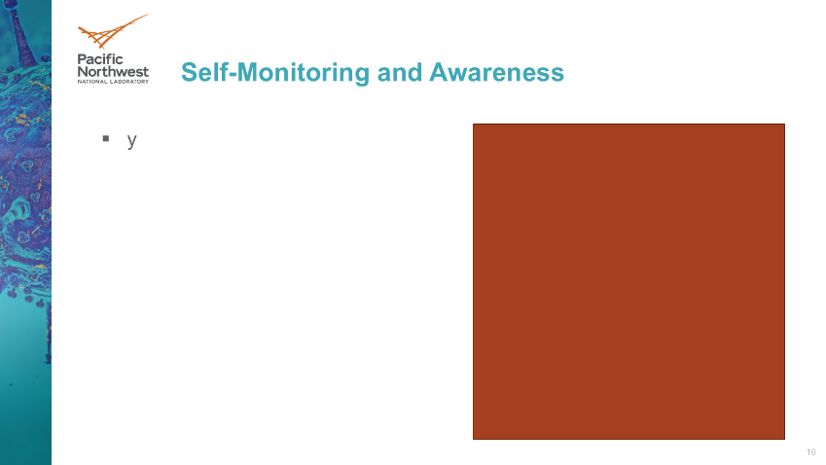
Self-Monitoring

Facilitator Notes:

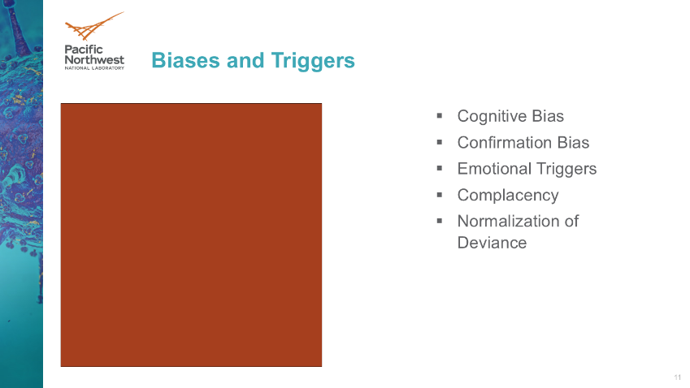
Biases and Triggers

Facilitator Notes:

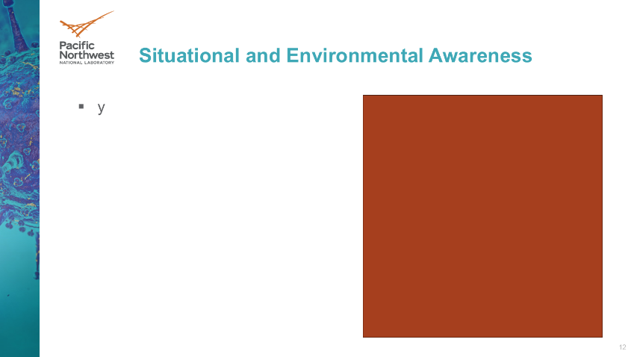
Situational and Environmental Awareness

Facilitator Notes:

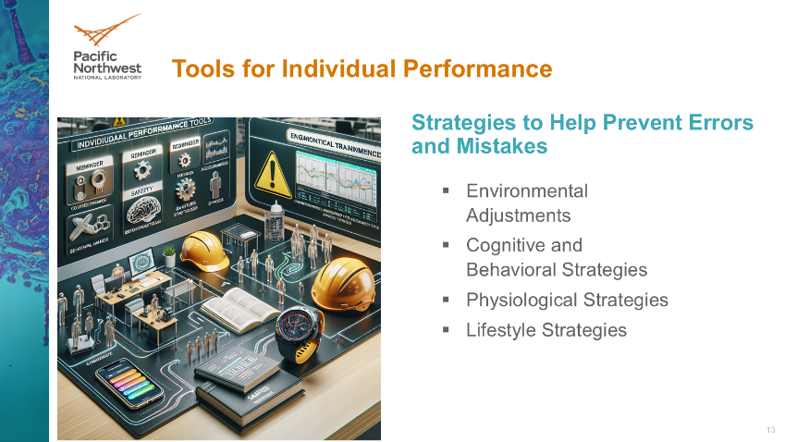
Tools for Individual Performance

Facilitator Notes:

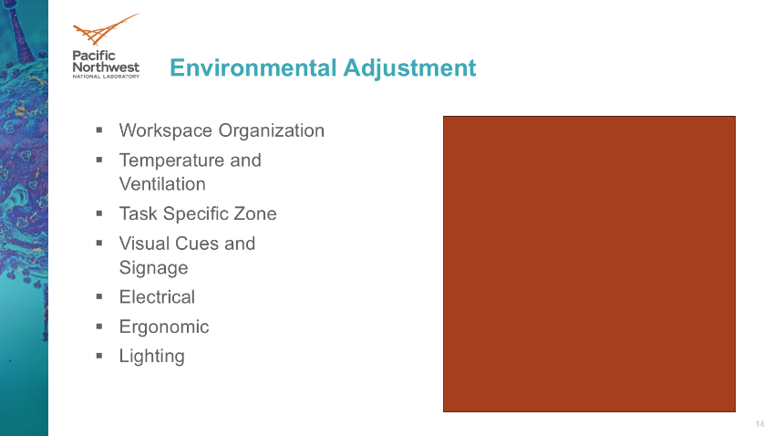
Environmental Adjustment

Facilitator Notes:

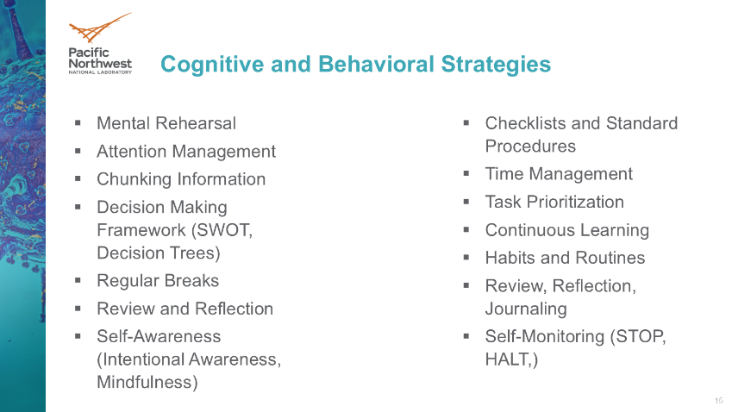
Cognitive and Behavioral Strategies

Facilitator Notes:


Scenarios

Facilitator Notes:

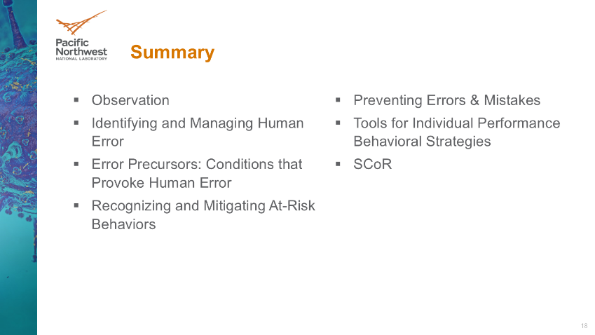
Summary

Facilitator Notes:


Thank you
Thank you for attending and participating in this engagement on Safety and Performance Through Self-Awareness.

Facilitator Notes:
Dismiss the participants and thank them for their attendance and participation.

